- How do you use the "cp" command to copy a file named "file.txt" from the current directory to a directory named "backup"?
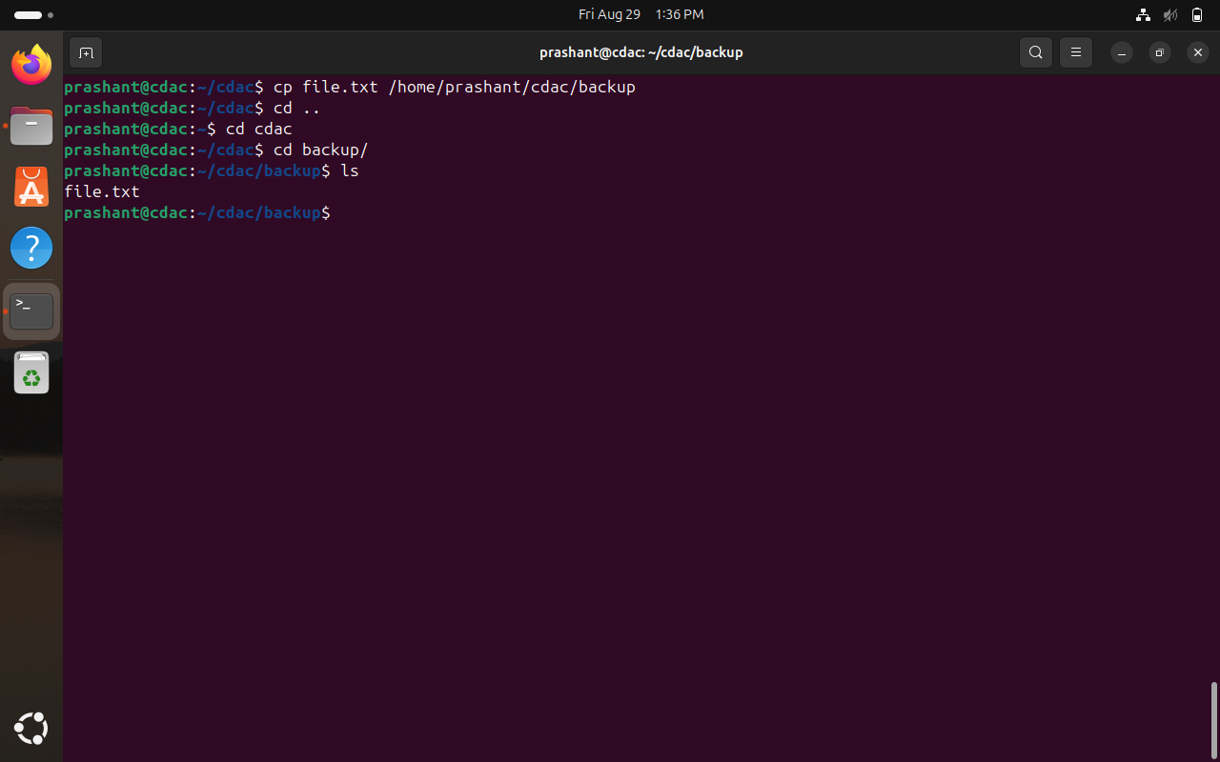
- What is the difference between the "rm" and "rm -r" commands in Linux?
rm removes files only.
rm -r removes directories and all their contents too.

- How do you use the "mv" command to rename a file named "oldname.txt" to "newname.txt"?
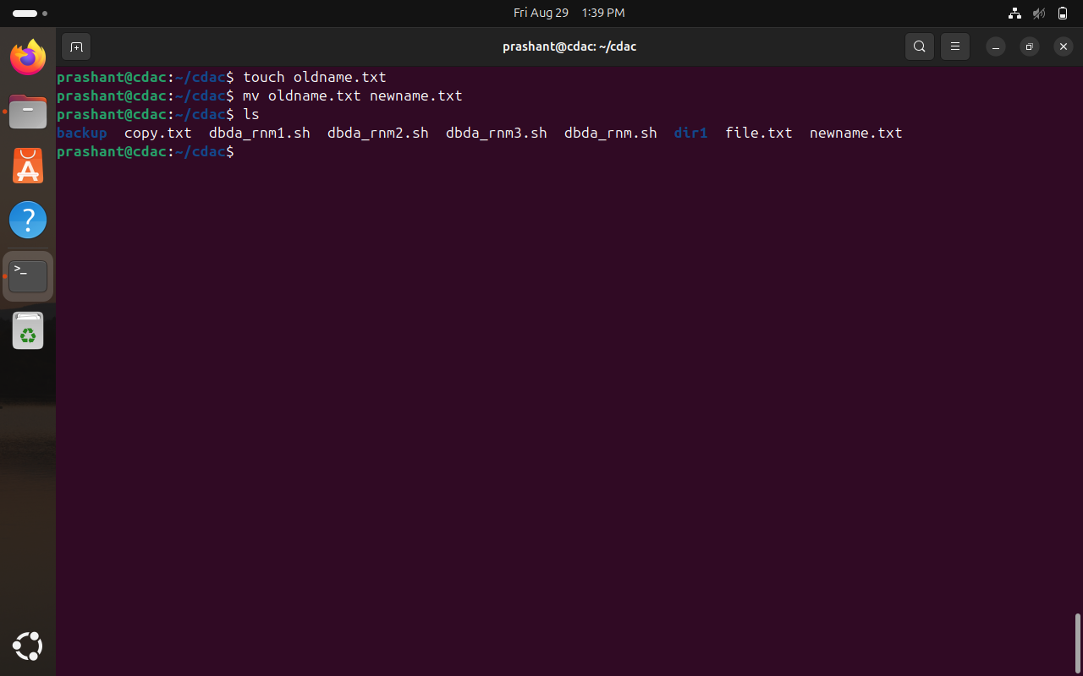
- What does the "pwd" command do in Linux?
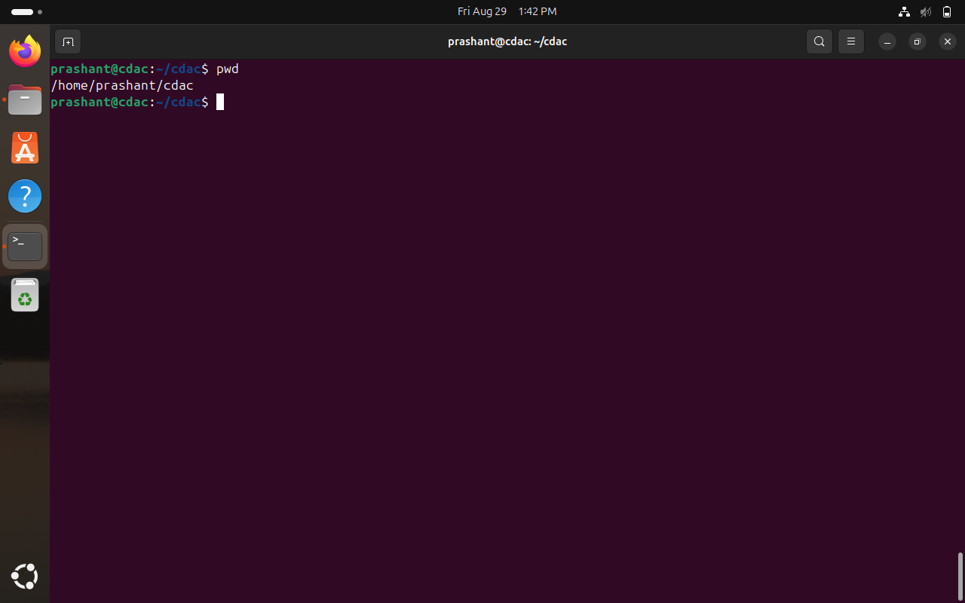
- How do you create a new empty file named "newfile.txt" in the current directory using the command line?
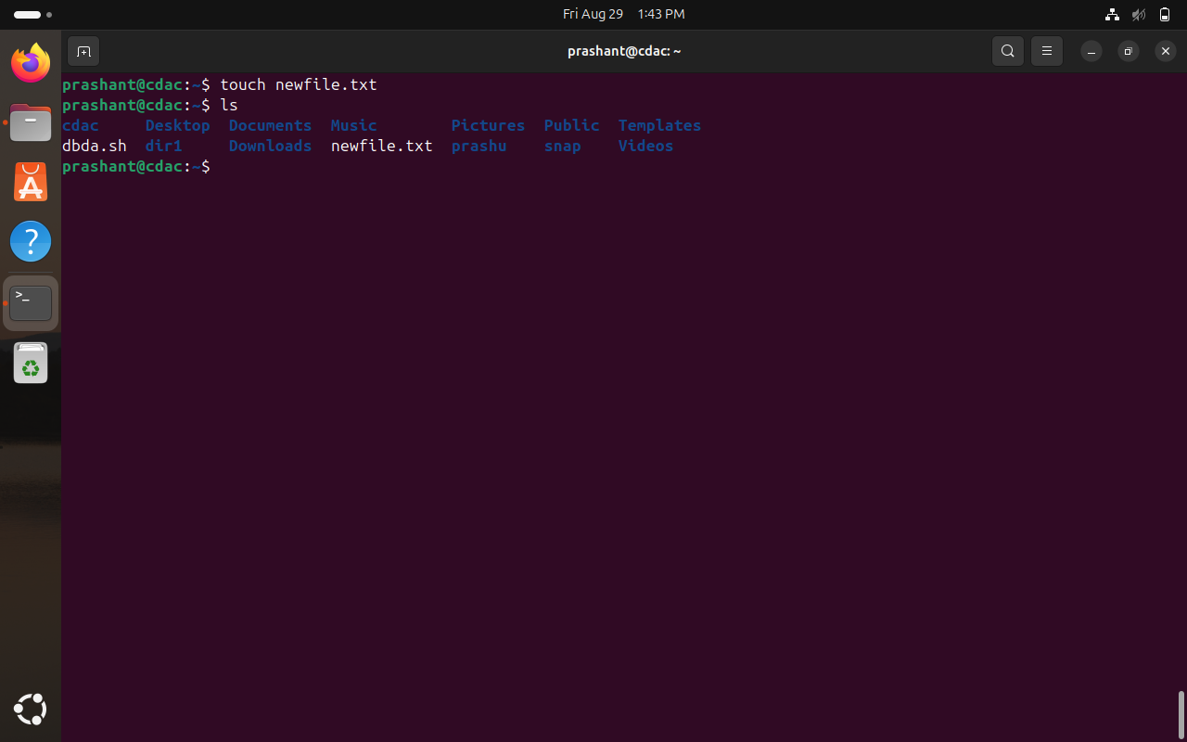
- How do you rename a file named "oldname.txt" to "newname.txt" using the command line?
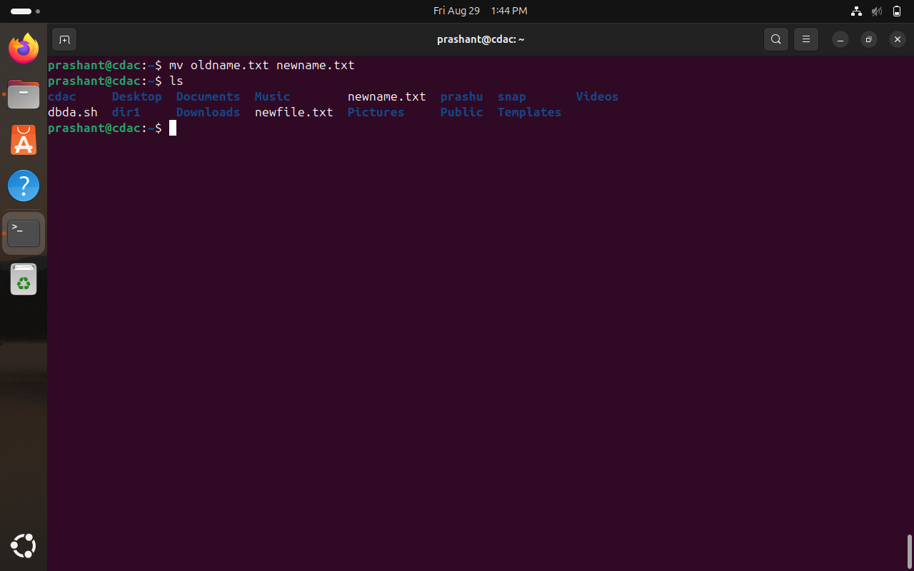
- How do you remove a file named "file.txt" from the current directory using the command line?
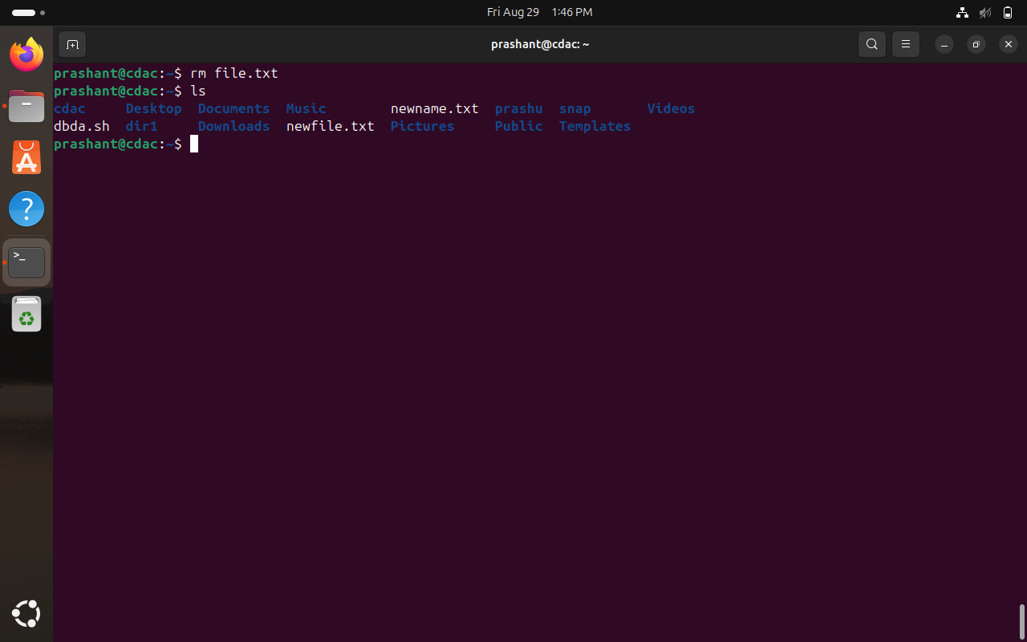
- Use a command to show the current working directory
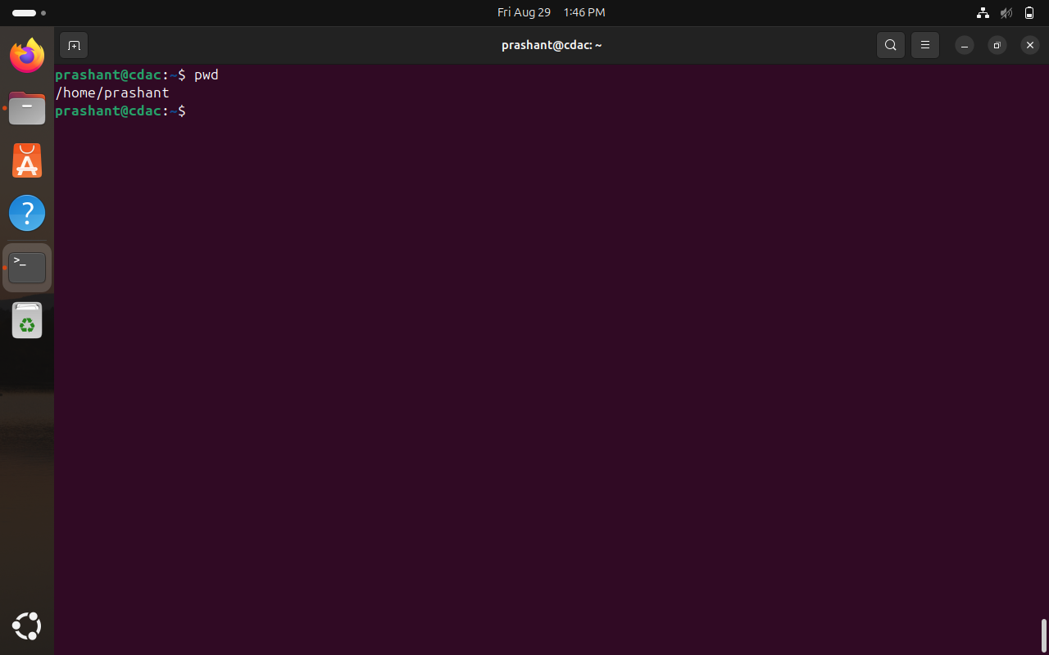
- List the directory contents in the short and long format
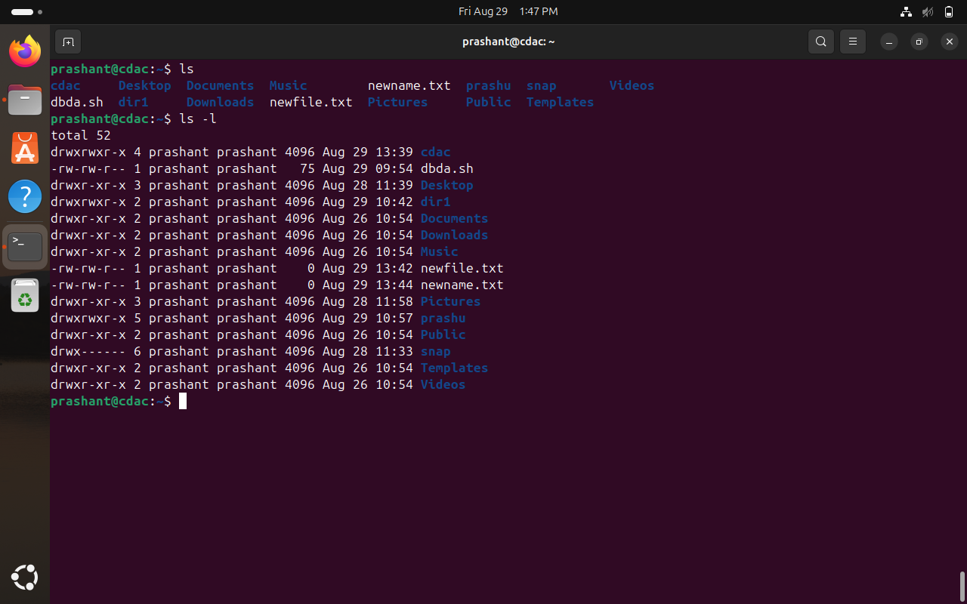
- Explore attributes given in long format e.g. file type, file permissions, file size, file owner etc.
- - : Regular file
- rw- : Owner (prashant) has read and write permissions
- rw- : Group (prashant) has read and write permissions
- r-- : Others have read-only permission
Links: 1
Owner: prashant
Group: Prashant
Size: 75
Last modified on August 29 at 09:54.
File Name: dbda.sh
- List all files along with hidden files in the current working directory.
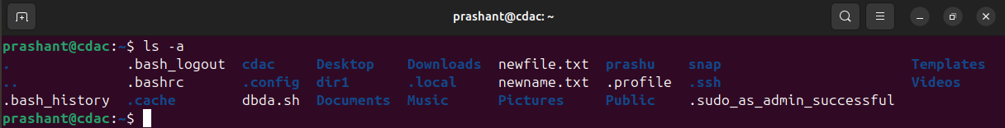
- list only hidden files in the directory
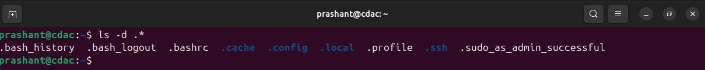
- Make a directory and name it as cdac-dir ​and change the current working directory to the new directory.(Hint : use mkdir,cd​ commands). 3. Create following nested directories inside the current directory by invoking a single command for only one time.
Note : here root_dir is the current directory.
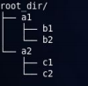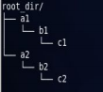
Directory structure 1 Directory structure 2
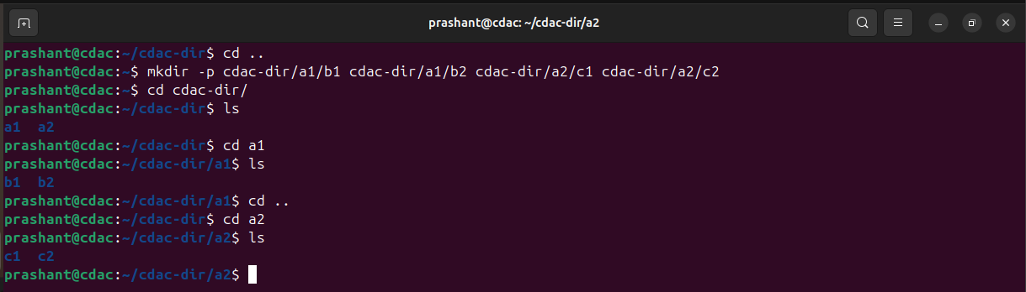
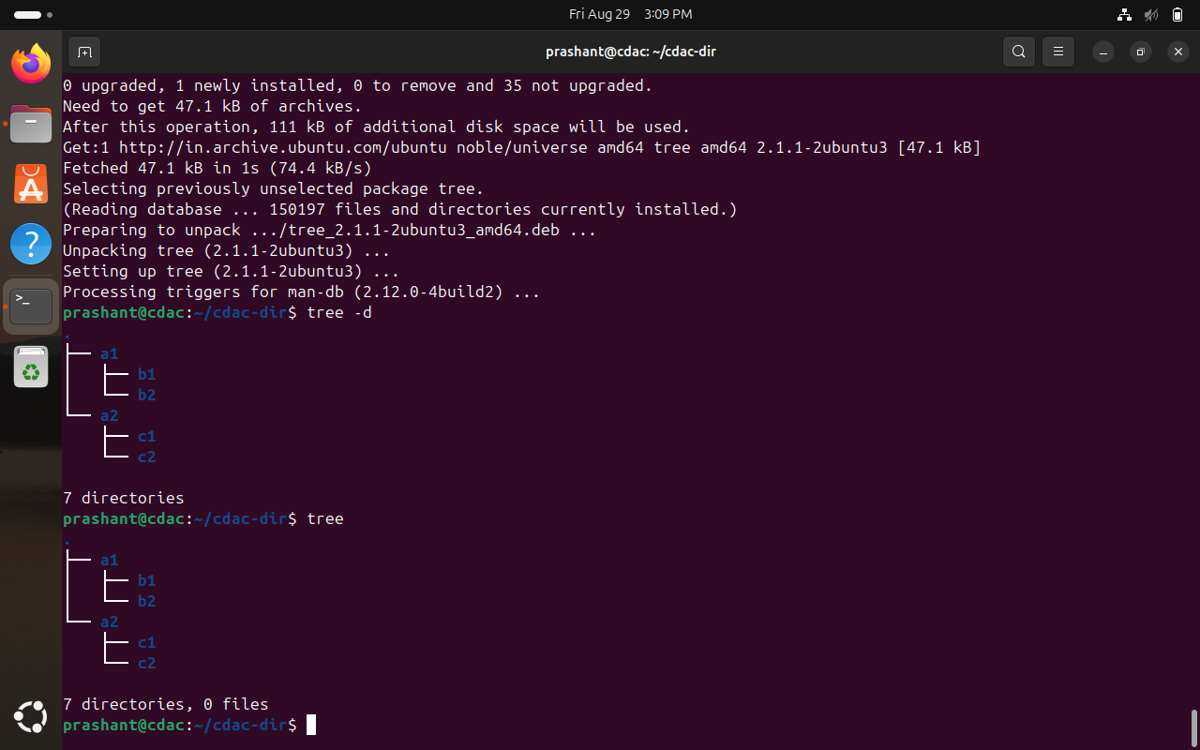
- (Hint : explore the man page of mkdir ​).
- 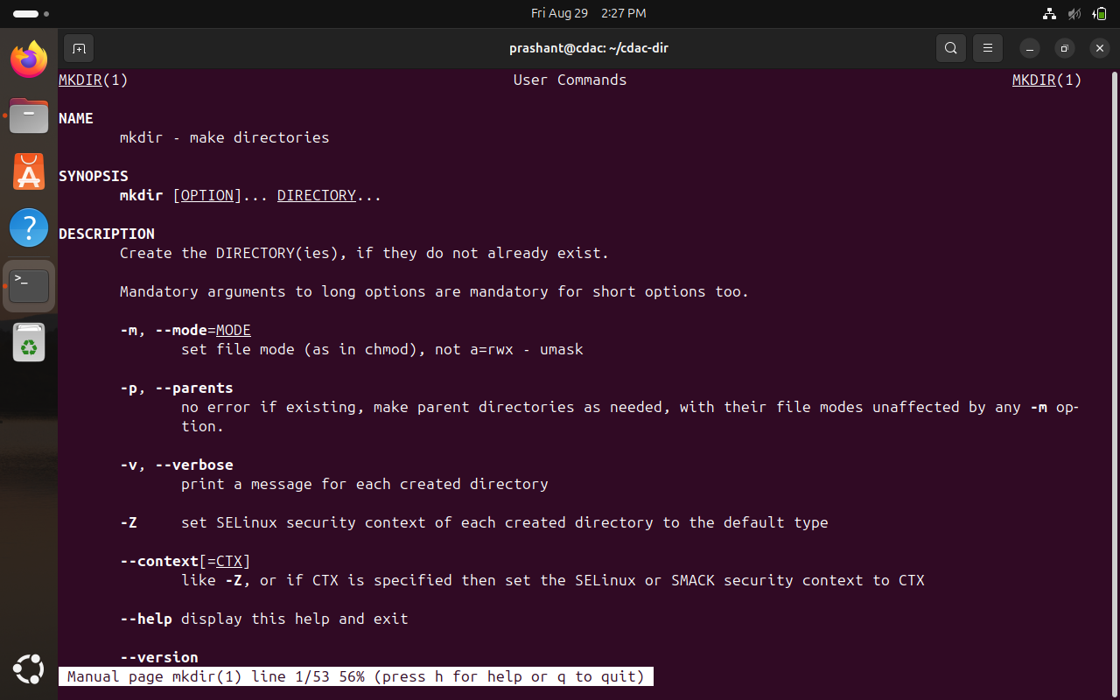
- List the directories(folders), then remove the cdac-dir ​directory and list the folders again to show that it is no longer present.(Hint : use rm, ls ​command
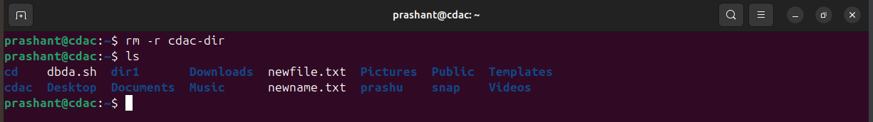
- Question-2.
- Display the man-page​ for ls​, but redirect the output into temp.txt​, then use the cat,​ less​, and more​ commands to display the new file.
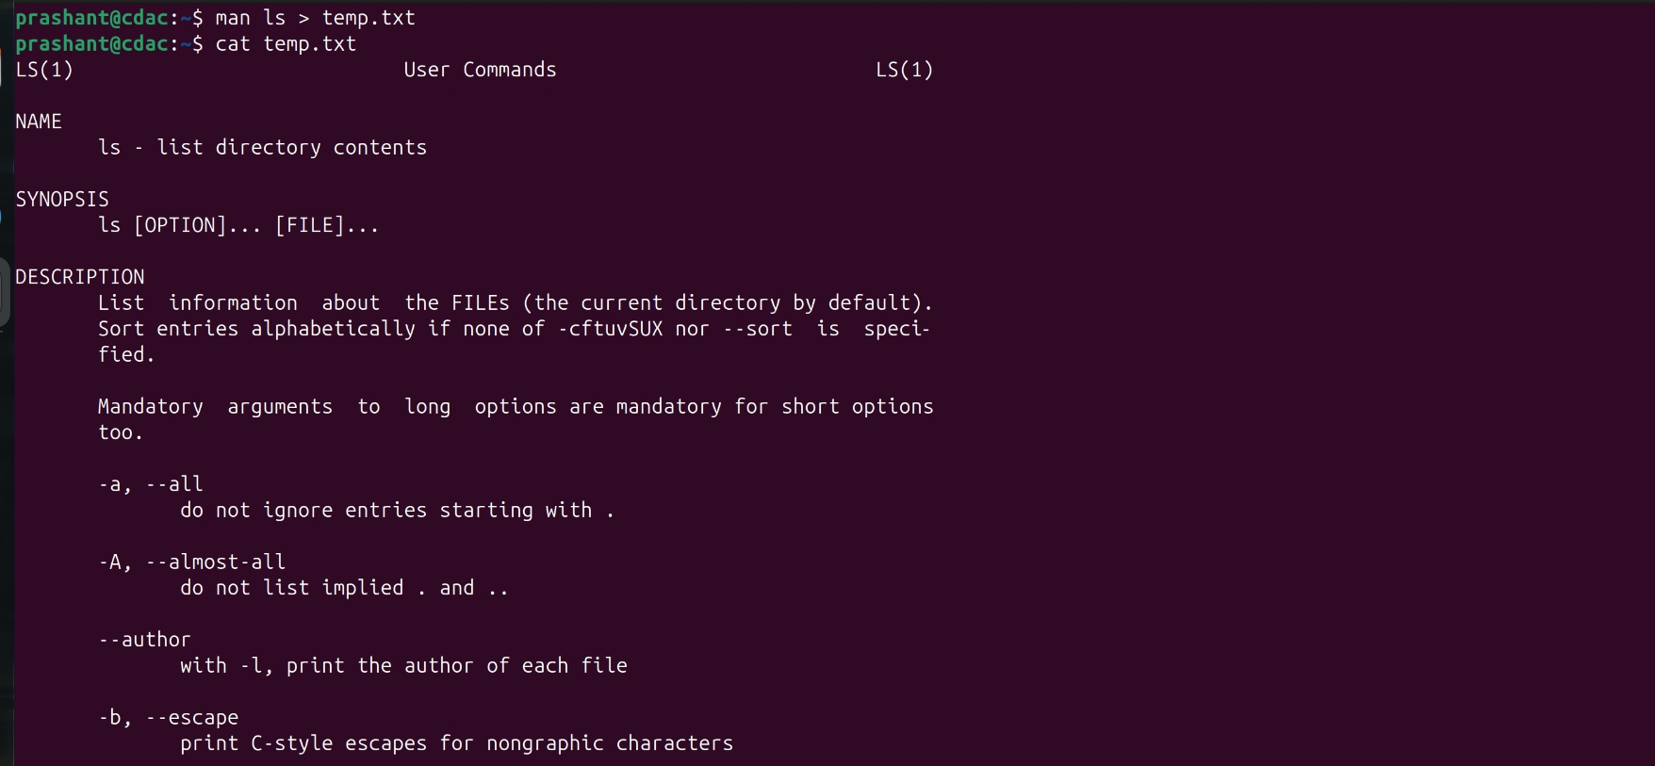
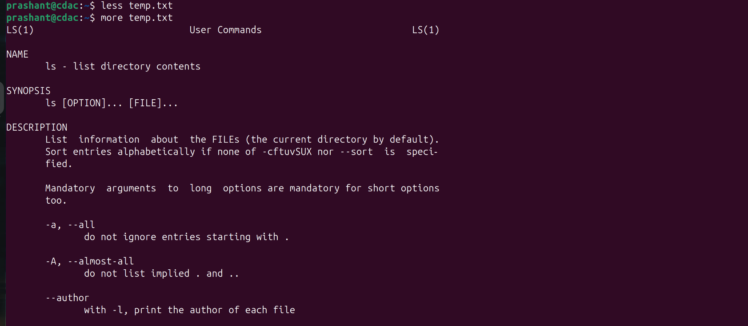
- Display the initial 10 lines and final 5 lines of temp.txt​ with the obvious Linux commands.(Hint: use head​ and tail​ commands).
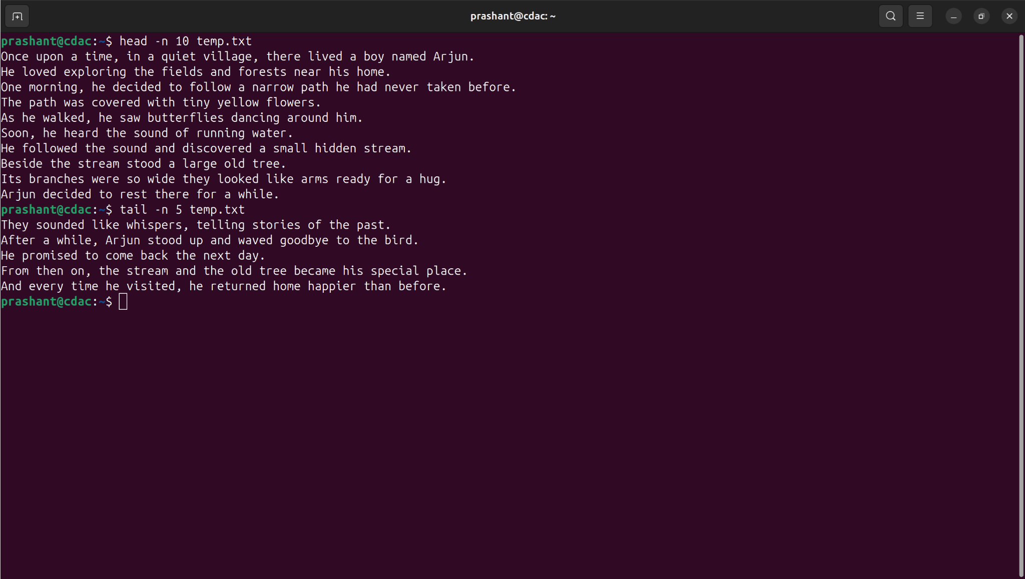
- Copy temp.txt​ to another directory and rename it there.
(Hint​: use cp​ to copy and mv​ command to rename).
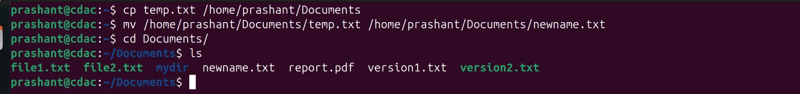
- Display the number of lines, words and characters in file using Linux command (Hint​: use wc ​command).
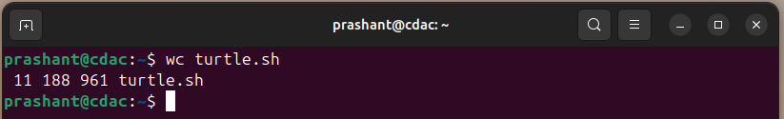
- Use history command to display the last 10 commands used. (Hint​: use history ​command).
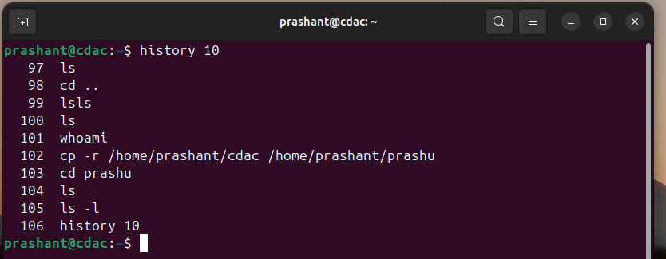
- Create a tar archive file of any directory present in your home directory. (Hint​: use tar ​command)
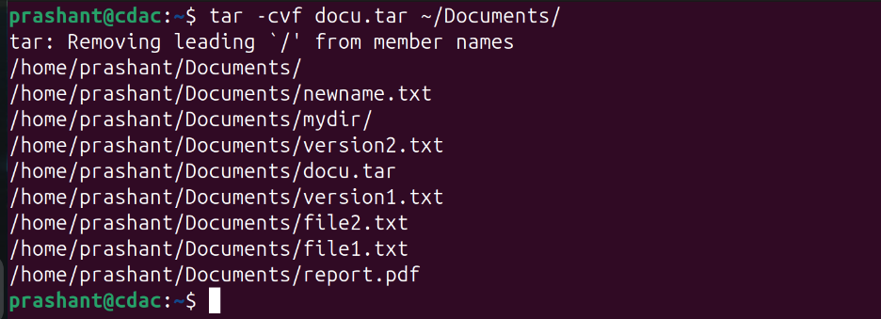
- Create a zip file of another directory. (Hint​: use zip ​command) - list the contents of the zip file without extracting.
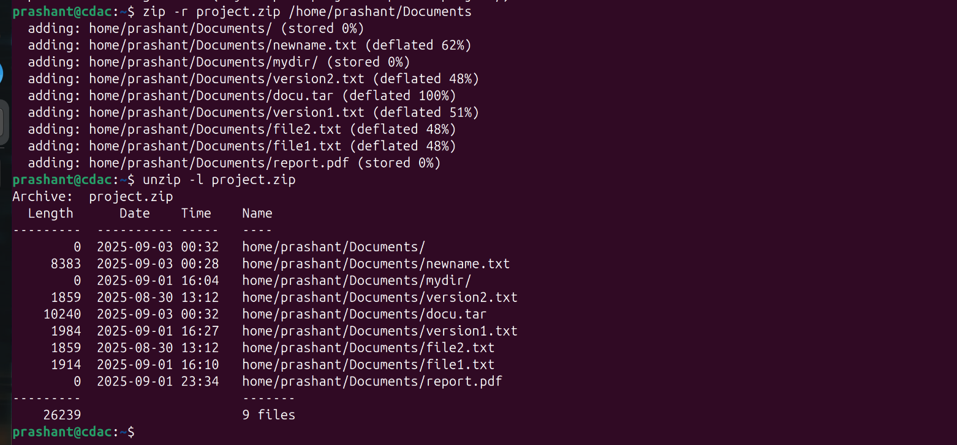
- Give read, write & execute permissions to your file. (Hint​: use chmod command)
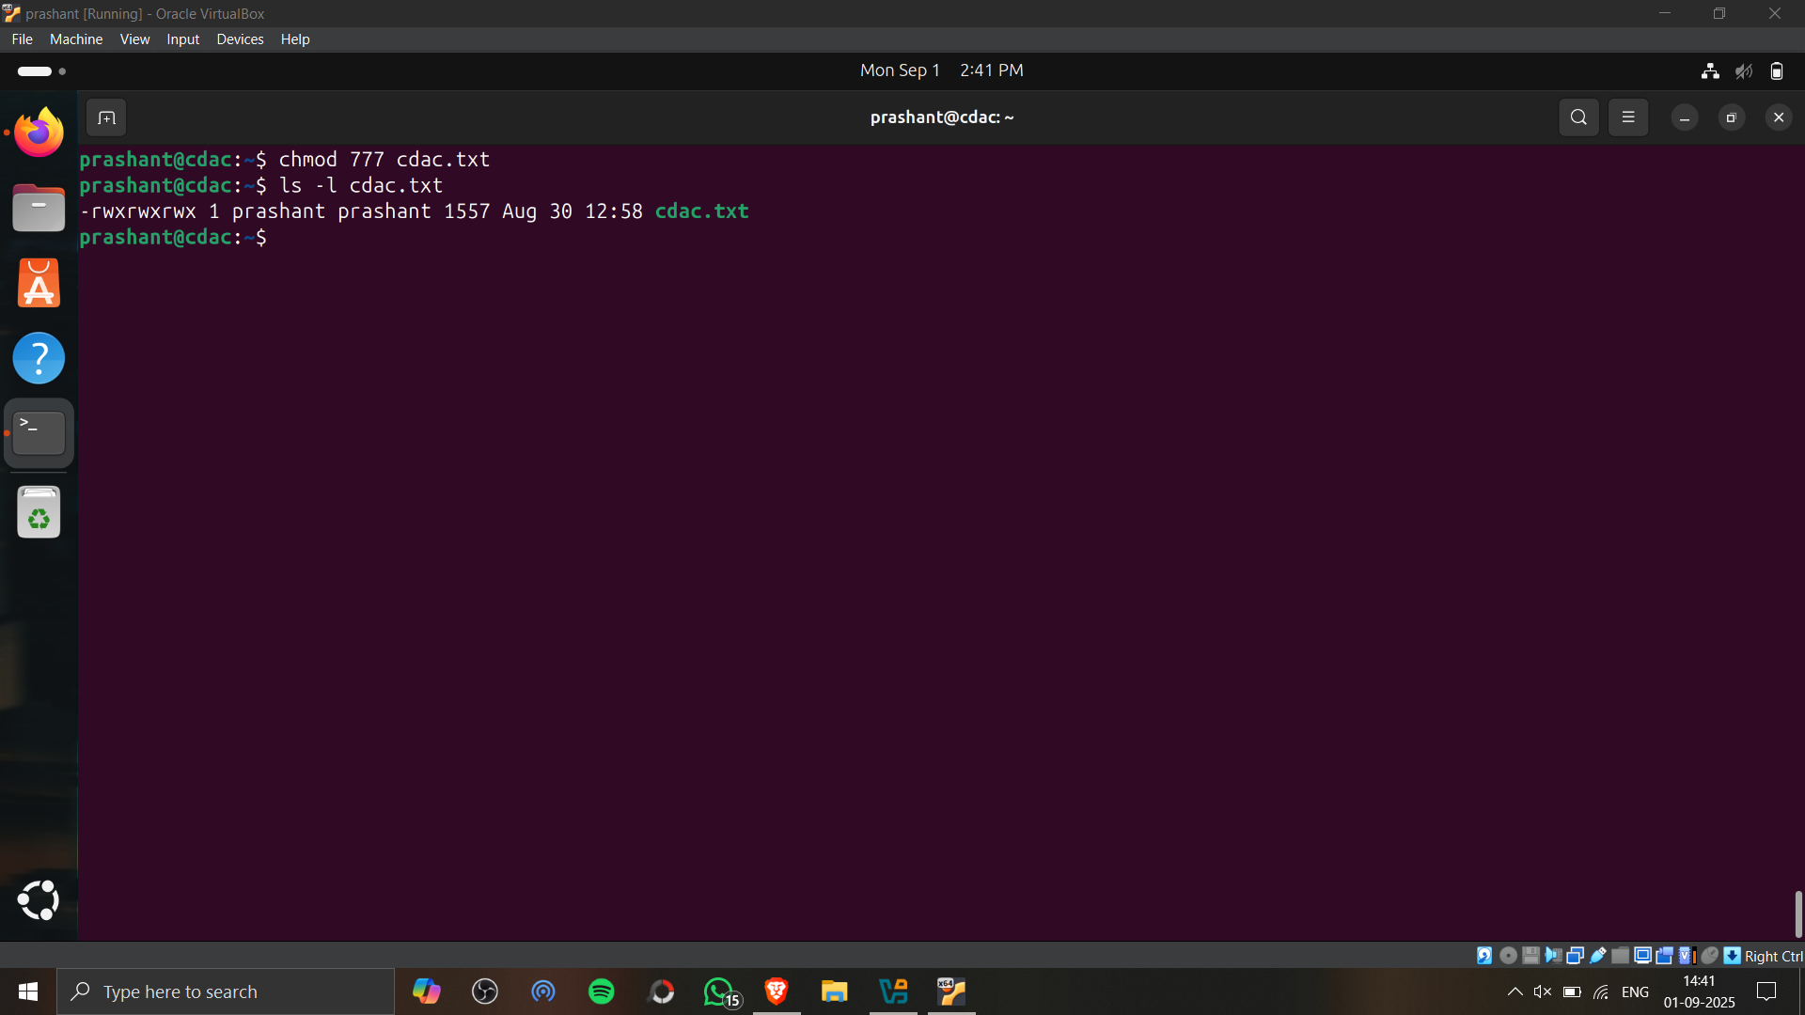
- Change ownership of that file.(Hint​: use chown​ command)
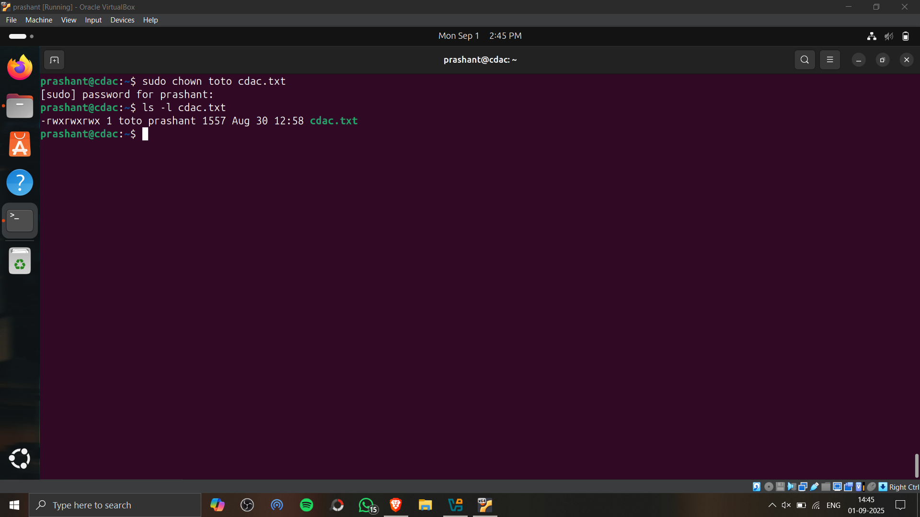
- List processes running in shell, all running processes(Hint​: use man page of ps ​command) and show top processes in decreasing order of their resource utilization.(Hint​: use top​ command).
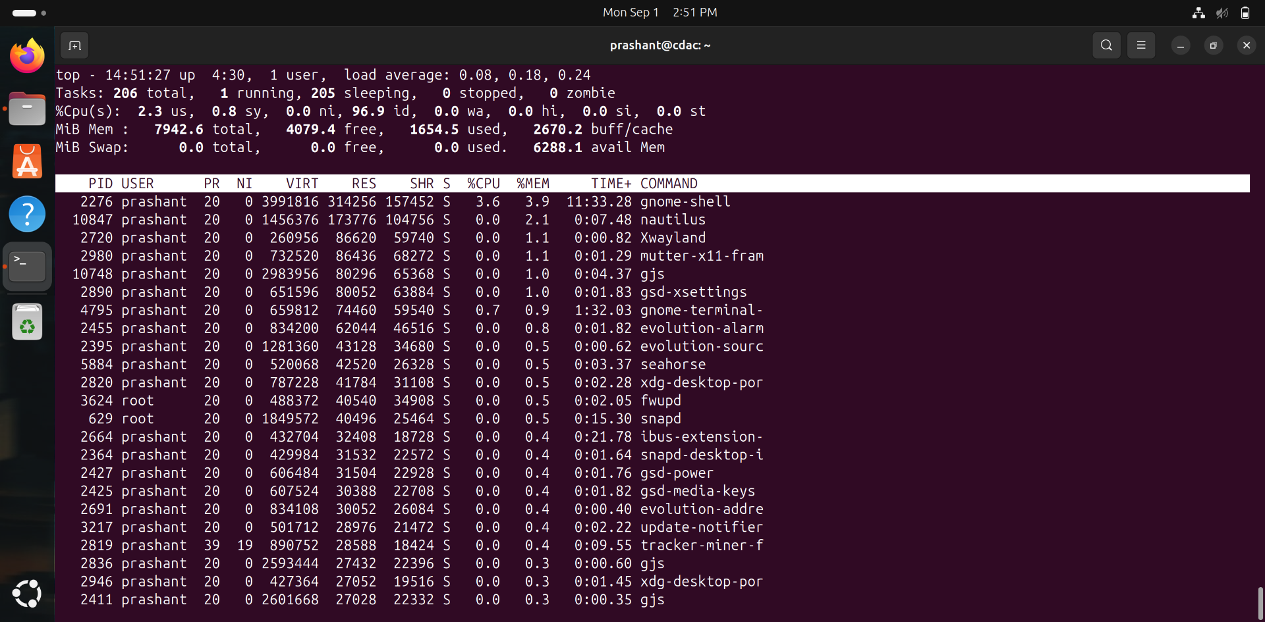
- Display current time and calendar (Hint​: use date, cal ​commands) 2. Change the current date and time of the system to following 14th March 2024, 10:10 AM
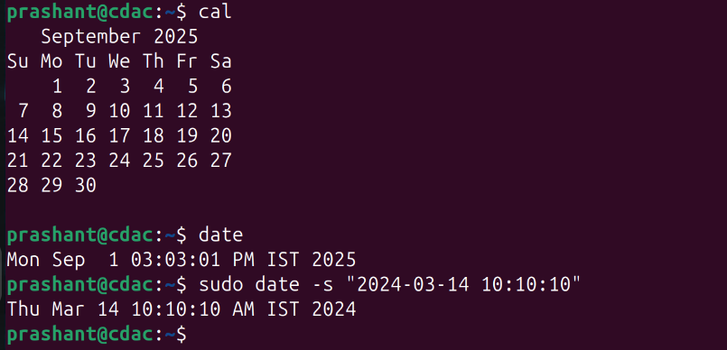
- Explore following commands
who, whoami, whatis, whereis, (Hint​: use man pages).\
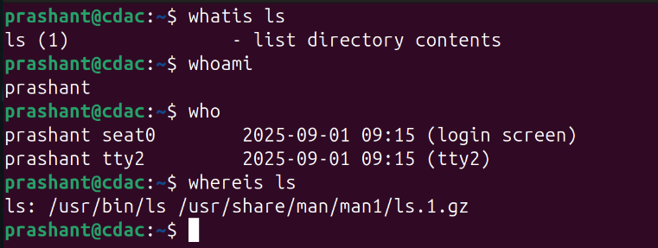
- Create one directory named linux. cd to that directory and create one file named testperms.txt. ​Check the permissions of that file. Check the value of umask​. Change the value of umask and create one new file newtestperms.txt ​and check its permissions. Note down the difference.(Hint: use umask, ls command )
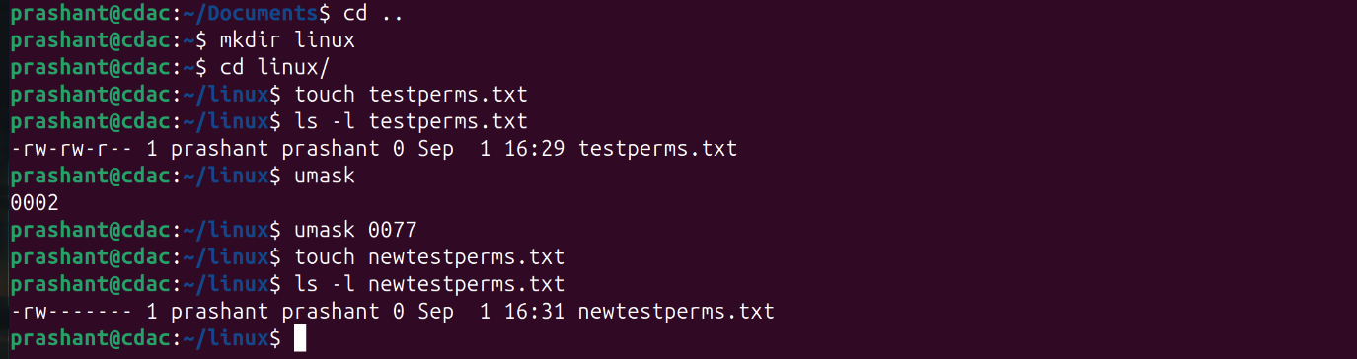
- Create a file and name it as file1.txt and create a hardlink to this file. (Hint: use ln​ command).
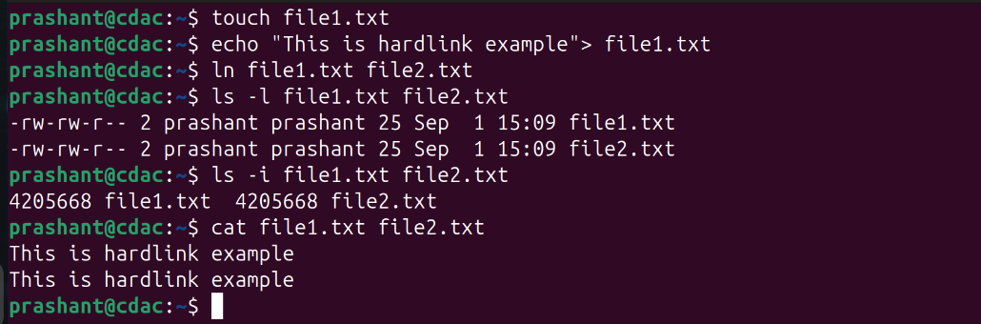
- Create a file and name it as file2.txt and create a softlink to this file. (Hint: use ln​ command).
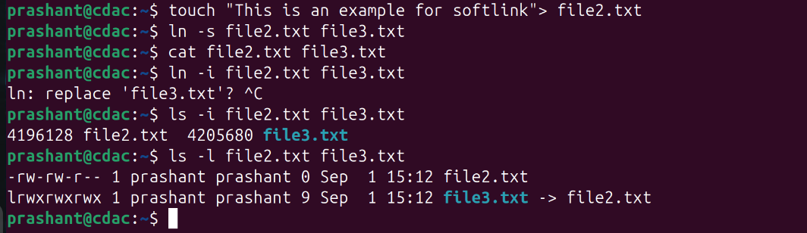

Hard Link | Soft link
Hard line with being a link. | Soft link is a link which indicates path to  its parent file.
Since it is a file by itself, if parent file is  deleted, child file remains as it was  previously. | Since its a path, if parent file is deleted,  child doesn't point tp proper path and  becomes a zombie file.
Can be used for creating backup files. | Can be used as a shortcut.
Syntax is: In parentfile.ext childfile.ext | Syntax is: In -s parentfile.ext Q  childfile.ext (here, -s indicates soft link)
- Use ssh​ to connect to your friend's shell by specifying port number​ in the ssh command. use exit ​command to come out of your friends shell.
(Hint: use ssh​ command)
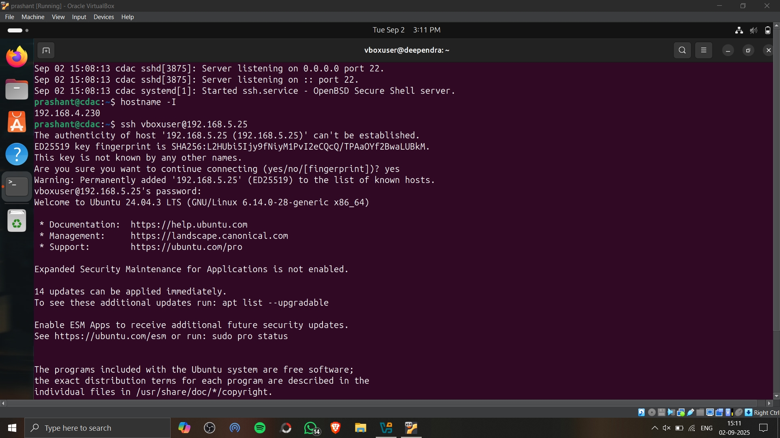
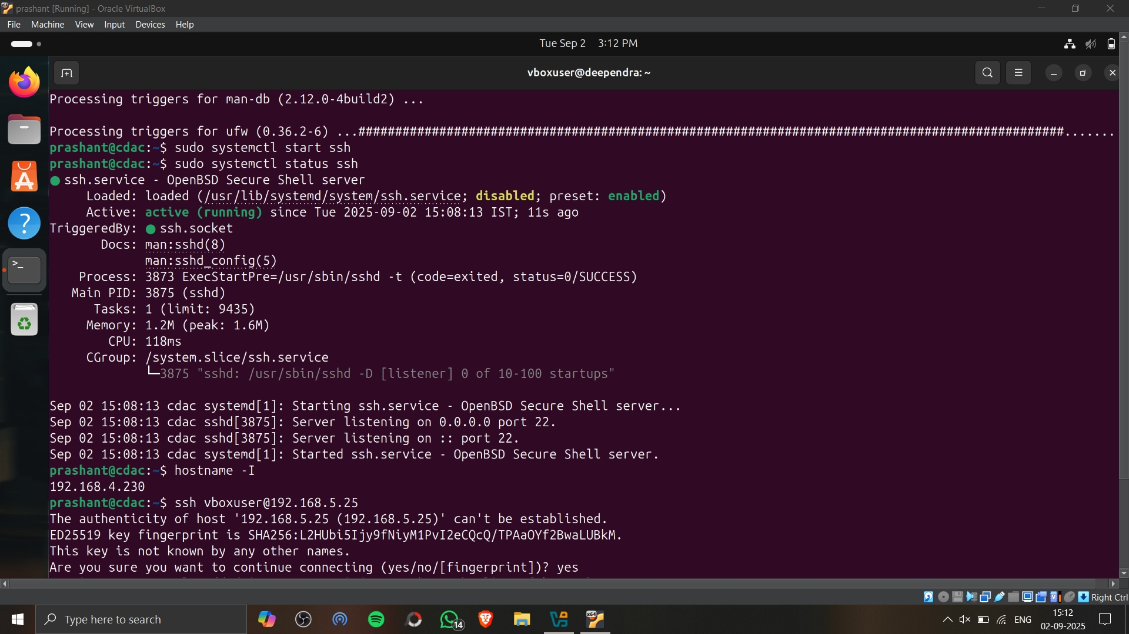
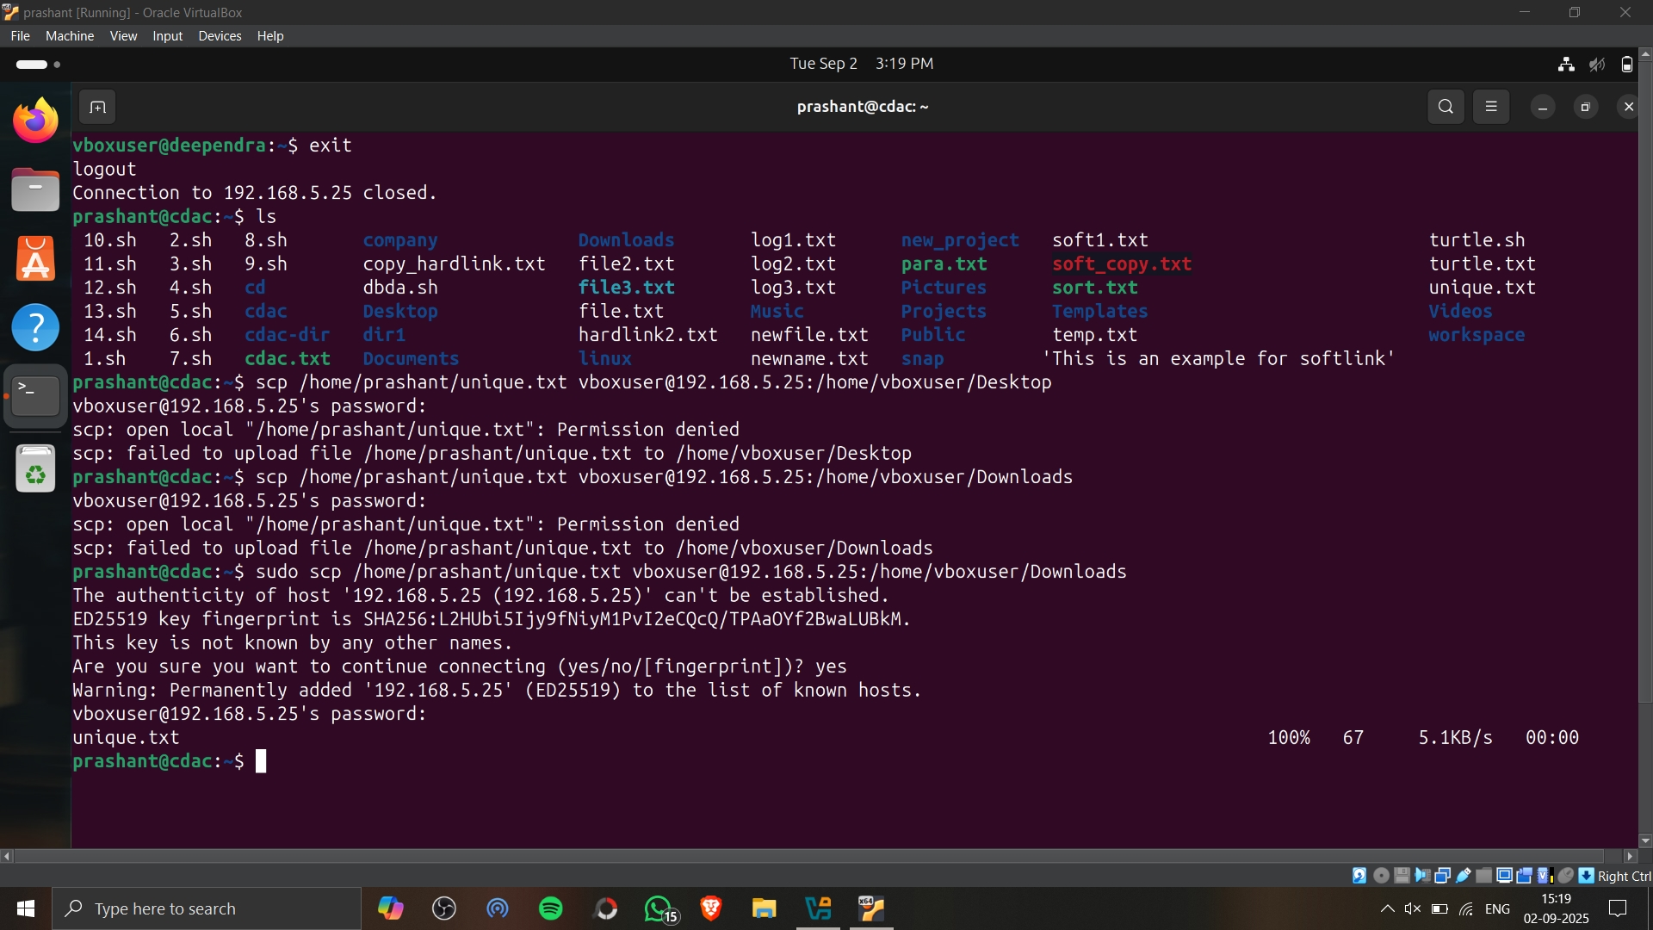

- Use scp​ using your friend's credentials to copy a file​ into a directory owned by your friend, ​inside his home directory, specify port number in scp​ command.

- Use scp​ using your friend's credentials to copy directory​ into a directory owned by you​, inside your home directory, specify port number in scp command
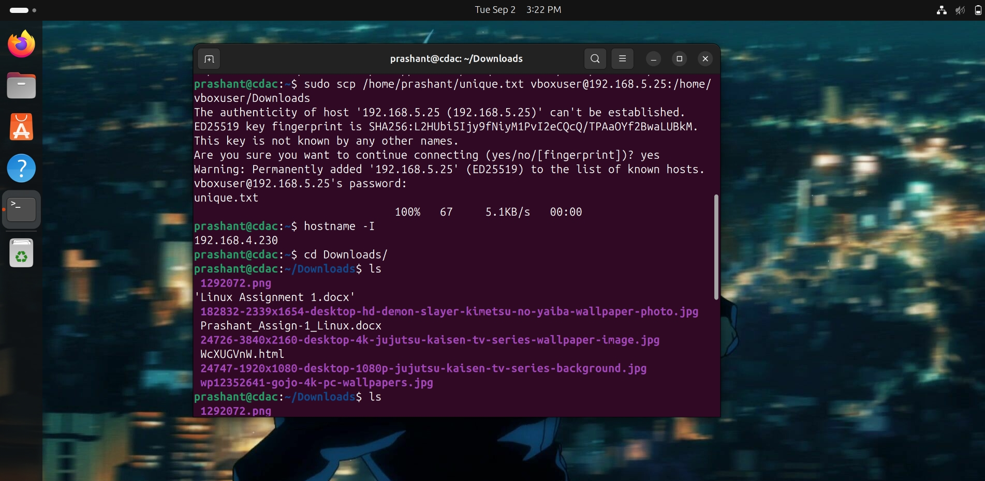
- Use scp​ using your friend's credentials to copy directory​ into a directory owned by you​, inside your home directory, specify port number in scp command

- Connect to any publicly available ftp​ server from the terminal and try to download, upload and delete files. If you get error in any process (connect, upload, download or delete), justify the reasons behind them.(Hint: use ftp​ command) Example:
Try to access ftp.netbsd.org
username : anonymous
password : anonymous

- How do you remove a directory named "mydir" and all of its contents using the command line?
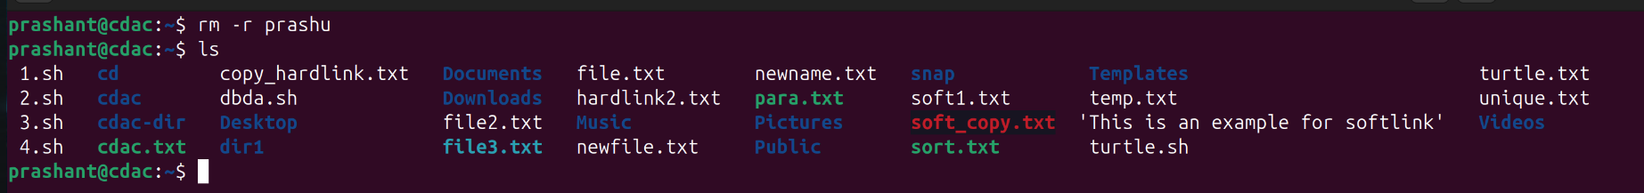
- How do you use the "ls" command to list all files and directories in the current directory?
- How do you create a new file named "myfile.txt" in the directory "/home/user/documents" using the command line?
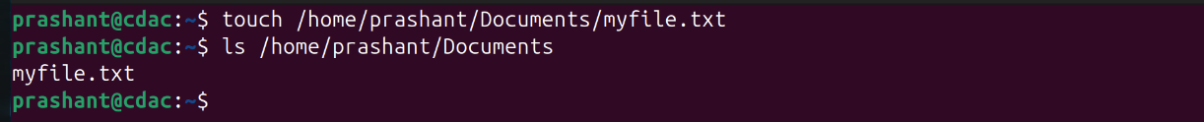
- How do you use the "grep" command to search for a specific word or phrase in multiple files at once?
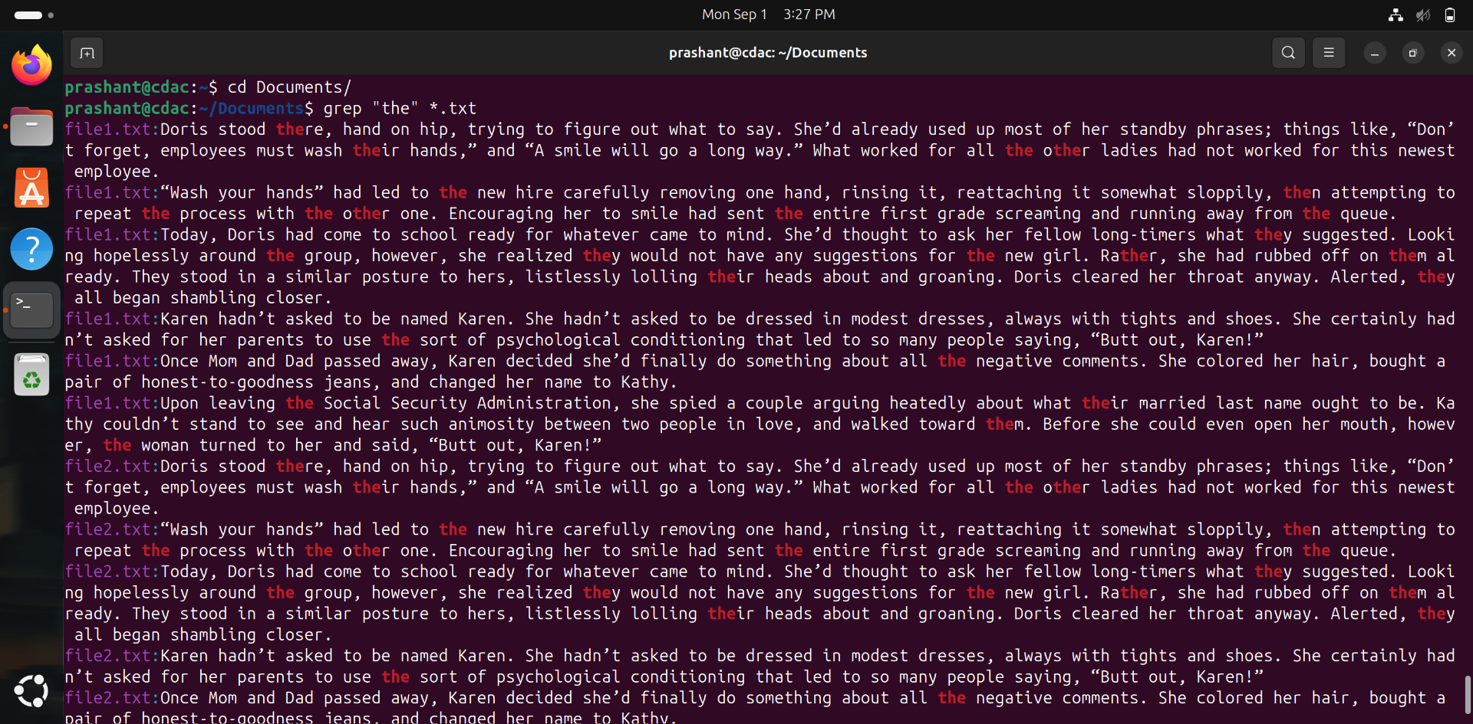
- How do you create a new directory named "mydir" and set its permissions to read, write, and execute for the owner and read and execute for everyone else?
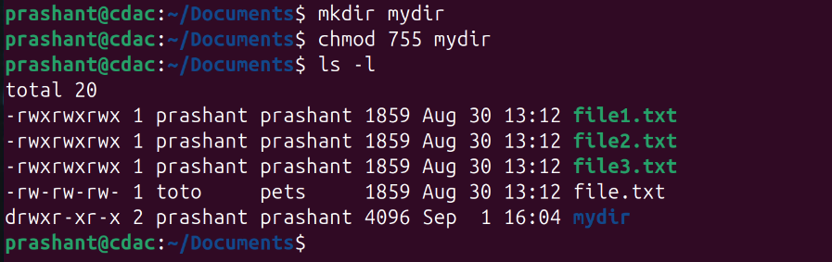
- How do you use the "tar" command to create a compressed archive of all files in the current directory and its subdirectories?
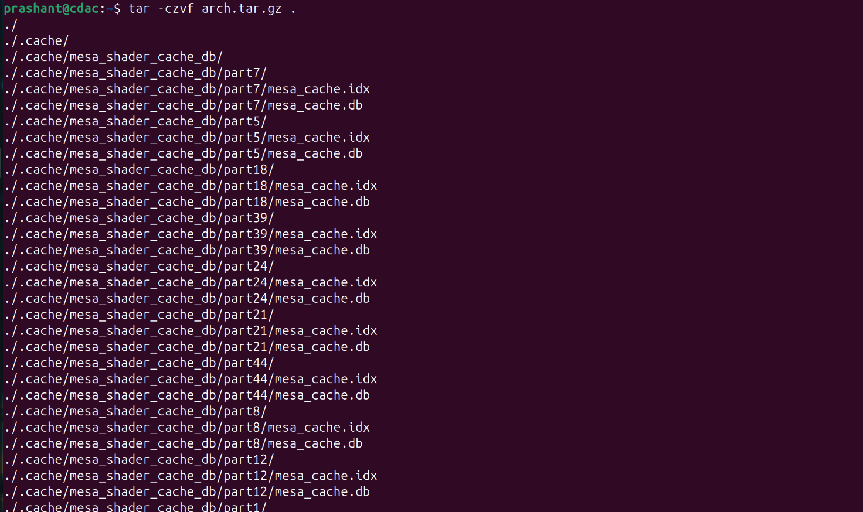
- How do you use the "chmod" command to give read and write permissions to the owner and group for a file named "file.txt"?
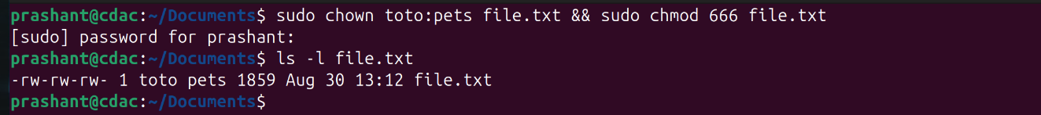
- How do you find the size of a file named "file.txt" in bytes, kilobytes, and megabytes using the command line?
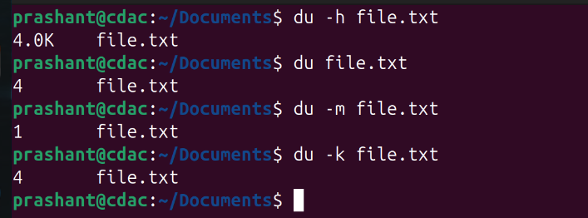
- How do you use the "awk" command to extract a specific column from a comma-separated value (CSV) file and sort it in reverse order?
- How do you use the "sed" command to replace all occurrences of a word or phrase in a file with a different word or phrase?
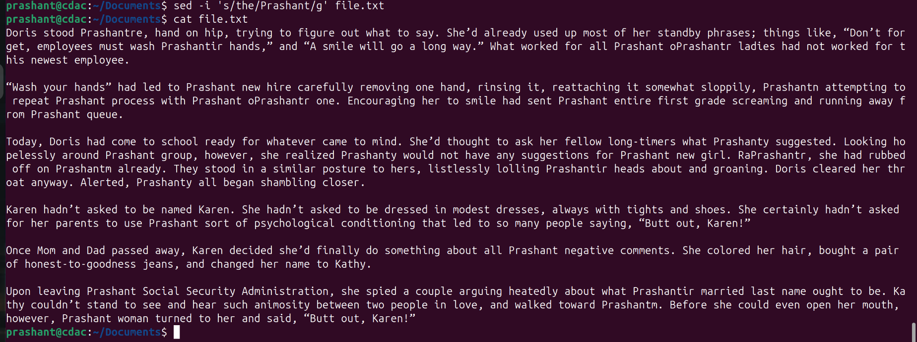
- How do you use the "find" command to search for all files in a directory and its subdirectories that were modified within the last 24 hours?
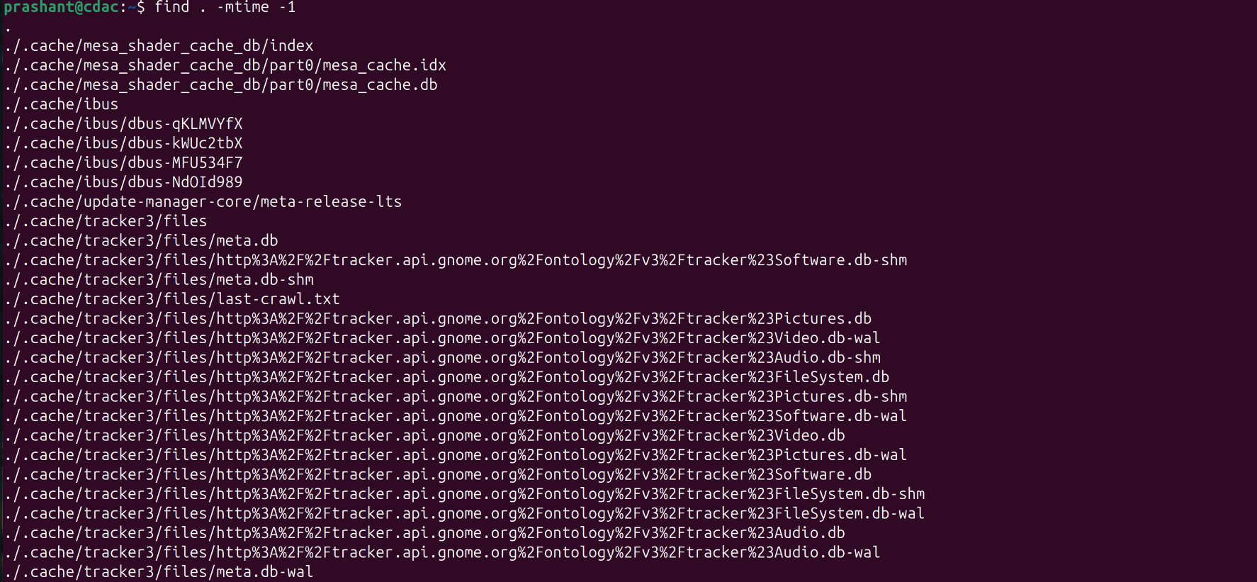
- How do you use the "diff" command to compare two files and show only the lines that are different between them?
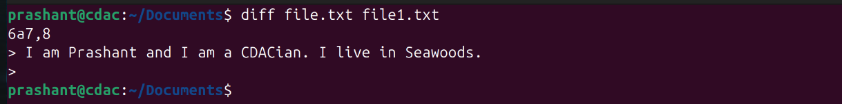
- How do you use the "rsync" command to synchronize the contents of two directories, including all subdirectories and files, while preserving file permissions and ownerships?

- How do you use the "cut" command to extract a specific range of characters or bytes from a file?
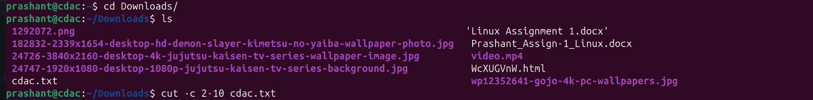
- How do you use the "tar" command to extract a specific file or directory from a compressed archive without extracting the entire archive?
- How do you use the "awk" command to count the number of occurrences of a specific word or phrase in a file?

